Bobbie Noonan’s Child Care
One’s News

April 24 – May 5 Week #35 & Week 36
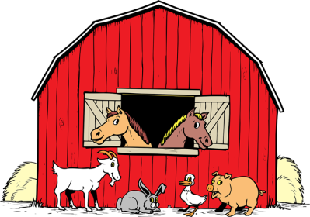
Theme: Farm
Introductions: None
Bits: None
Manners: “Say Please and Thank You”
Vocabulary: None

Language: In Language class, we always begin by singing our, “Welcome Song” and playing our name recognition game. The finger plays will be, “In the Barnyard”, “Farmer”, “The Hens” and “Old McDonald Had a Farm”, “Five Little Farmers” and “Five Little Potatoes”. The puppet plays we will be, “Little Cow” and “Five Little Chickens”. We will also enjoy story and music time!

Craft & Writing: In craft class, we will paint a picture of a pig. We will mosaic a dog, glue black spots on a cow, glue cotton balls on a lamb and glue a tail on a horse. We will also glue animals in a barn to learn the textures of the animals and where they live on the farm. Playdoh will also be enjoyed.

Concept: In Concept class, we will enjoy stacking and matching toys along with reviewing our colors, shapes and numbers. A game that is loved that helps us review our numbers is called “Bug Splat”. One to one correspondence will also be reviewed with our matching activities. Sand play and puzzles will also be a big hit these next two weeks.

Motor: In Motor class we will have fun with ball play, the ball and wand and learning how to toss the ball into a basket. We will also enjoy the parachute, bowling, the tunnel, the boat, stair climbing and as always we will enjoy our body parts song.

UPCOMING EVENTS:

Apr. 25 Photo packages available for purchase
(cash and credit cards accepted, no
checks please)
May 8th Parents’ Day
May 29th Memorial Day – School Closed

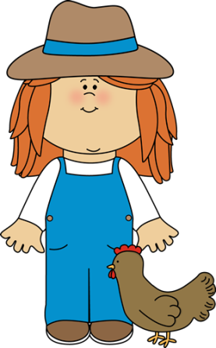
REMINDER: As an effort to keep our room as germ free as possible, PLEASE be sure to wash your child’s hands when coming into school. Please remember to send your child to school in closed toe shoes to help prevent accidents on the playground. Thank you!

PLEASE BE SURE YOU ARE CHECKING YOUR CHILD’S FILE DAILY!!
HAVE A GREAT WEEK!
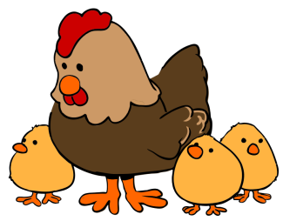
Ms. Nicole & Miss Madison

