Sunday | Monday | Tuesday | Wednesday | Thursday | Friday | Saturday
 |  | 1  Griled Cheese  Tomato Soup  Green Beans,  Celery Sticks | 2  Chili  Vegetable  Cucumber Slices | 3  Tuna Casserole  Broccoli  Carrot Sticks | 4  Meatloaf/  Meatballs  Potatoes  Peas  Broccoli  Tomato Wedges | 5
6 | 7  Daycare Week (No Preschool)  August 7th – 11th | 8 | 9 | 10 | 11 | 12
13 | 14  First Day of School | 15 | 16 | 17 | 18 | 19
20 | 21 | 22 | 23 | 24 | 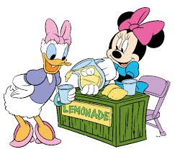  25 | 26
27 | 28 | 29 | 30 | 31
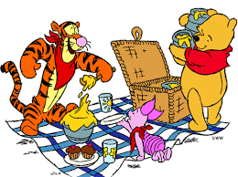
August 2017

