2017-2018 school year Open house

Please join us on Wednesday, August 9th from 5:00 pm to 6:00 pm to meet your child’s VPK teacher!
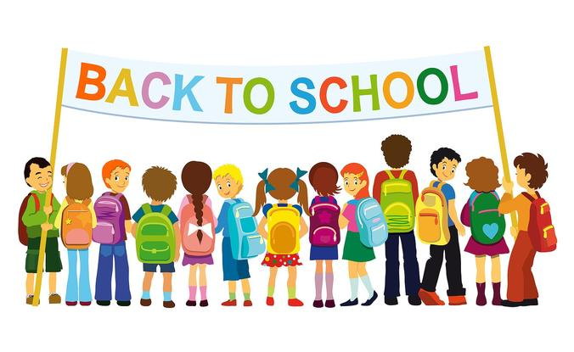
This open house is for children who will be attending from 9:30 to 12:30

2017-2018 school year Open house

Please join us on
Thursday, August 10th from 6:30 pm to 7:30 pm to meet your child’s teacher!

