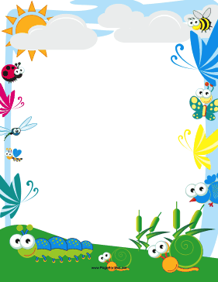

**Two’s News**

**May 9-20 Weeks 38 & 39 Theme: Creepy Crawlers**

**Special thanks to the families that recognized Teacher Appreciation Week!**

**Bits of Intelligence**: Sea Creatures

**Concept**: Ms. Sam is excited for bug week! The children will be BUZZING with excitement as they count bees in beehives. Butterflies will brighten up our week as we use them for a color matching game. The children will sort shapes on a caterpillar as well. Ms. Sam has some cool looking bug puzzles to add to our shelves. We will end the week by sorting bugs that fly vs. bugs that crawl. If the weather is pleasant we will take our magnifying glasses outdoors and go on a bug hunt.

**Language Arts**: Mrs. christine will work in the many new buggy flannel board stories such as “Five Little Fireflies” and “I’m a Little Ladybug”. We will also be talking about caterpillars and how they turn into butterflies. The children will love reading The Very Hungry Caterpillar. Sorting bugs will also help to expand our insect knowledge. The Itsy, Bitsy Spider is sure to make an appearance over the next two weeks.

**Craft and Writing**: The children will use many mediums such as paint, watercolors, crayons, markers and glue to make ants march, bees buss, butterflies flap, grasshoppers jump, spiders crawl and ladybugs fly right onto your fridge to show off their beautiful artwork.

**Motor**: We will use chalk outside to do a fun bug stomping game. We will get our bodies moving as we pretend to be bugs. As the weather is getting warmer, please make sure your child is wearing safe footwear for outside.

Happy Birthday Jordyn Kotyluk 5/16