Summer Camp 2022
Sprinkler Days

Summer has arrived! The bugs are buzzing and the sun is brightly shining. We will provide sunscreen for each child. If your child requires insect repellant please apply it at home.

Sprinkler days are back! The__________ area will have sprinkler day every_____________.
Beginning on____________. Please send in a bathing suit and a towel labeled with your child’s first and last name.
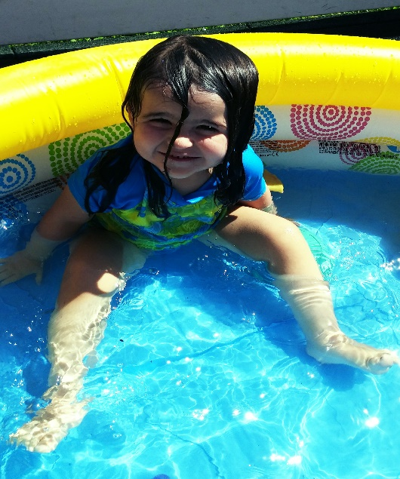
Thank you,
The Staff at Bobbie Noonan’s

