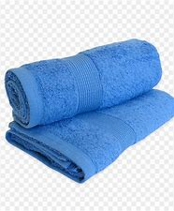

Dear Parents,

This summer we will be tie dying towels for your child to keep at school for our summer water days. Please send in one clean/new white bath towel by 6/8.

Thank you,

