Lockport’s Halloween Party Day
Monday, October 31st
Boo! It’s Halloween!

Our Halloween celebration will be on Monday, October 31st! All children are invited to attend from 9-12 if it isn’t your child’s normal day.
To celebrate the holiday the children and staff can dress in costume. Masks should not be worn to school because many of our little ones find Halloween just as enjoyable without the mask. Please limit the number of accessories on your child’s costume and make sure costumes are short enough to avoid tripping. Please help our school by adhering to our costume policy by not promoting scary or violent characters. Thank you in advance for your cooperation.
Please send your child to school in their costume. Day care and preschool parents please have an extra change of clothes for staff to change your child into after the party. If possible, please send your child to school wearing a change of clothing underneath their costume. Thank you so much for your help!
Halloween Treats:
If you wish to send in a snack for your child’s class please remember our food policy. We have an additive, preservative, and NO SUGAR policy. We are trying something new for this party. We are assigning what snack to bring. Please see below…

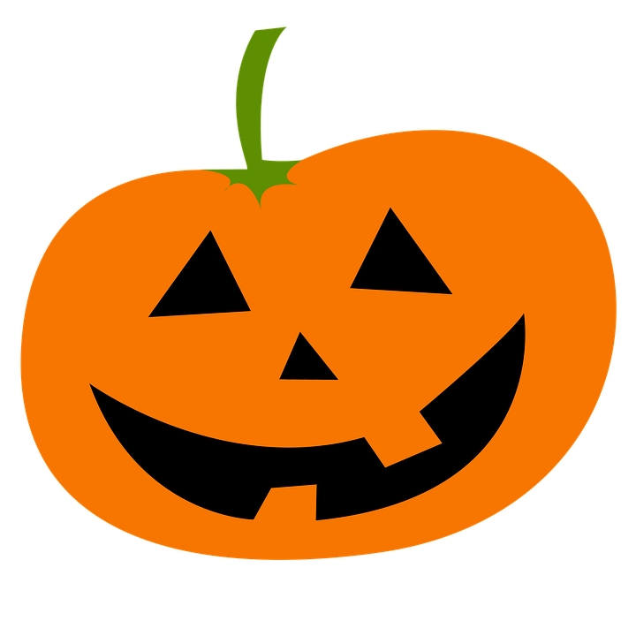

Class Totals:
Ms. Yasmin (Toddlers)- 6 (Veggies)
Mrs. Lauren (Nursery)- 13 (Fresh Fruit)
Ms. Katrina (Juniors)- 8 (2 Juicy Juice Bottles)
Mrs. Denise (Juniors)- 9 (Block Cheese Cubes)
Mrs. Ashley (Pre-K) 14- (Pretzels or Lay’s Potato Chips)
Ms. Riley (Pre-K) 13- (Goldfish or Pirate’s Booty)
Mrs. Munoz (Kindergarten) 7- (Veggie Straws)

