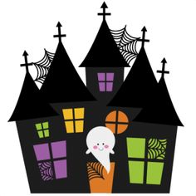 

Fire Prevention Month:

Did you know that October is Fire Prevention Month? This year, our school will have a Fire Prevention presentation for the children on Tuesday, October 18th! The children are taught how to line up, exit the building and locate our meeting place. This procedure helps us to reinforce what to do in case of a fire!

**Bobbie Noonan’s October Newsletter**

October 2022

Important Upcoming Events:

Our Picture Days will be on Monday, October 17th and Tuesday, October 18th!

Dial Screenings will be held at our school on 10/4, 10/5, 10/11, and 10/12!

Last Day of Soccer Shots is Tuesday, October 18th! Thank you Coach Maggie! It was a great season!

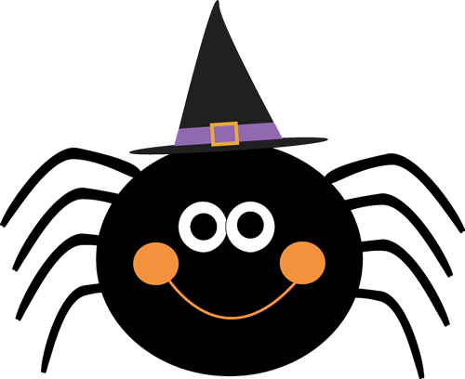

School Closed:

School will be closed on Monday, October 10th for a staff training day.

Each year the Bobbie Noonan’s Staff is required to attend at least 15 hours of in-service.

Normal Tuition is due this week. Thank you!



Lockport’s Trunk or Treat:

On Monday, October 31st we will be hosting our Halloween Trunk or Treat at 11:00am. This festivity will be held in our parking lot. Please decorate your cars if you are participating! Volunteers may also dress up in appropriate costume. ALL children may attend from 9-12 if they are not normally scheduled for Monday.

To celebrate the holiday, please dress your child in his or her costume. Costume Masks should not be worn to school because many of our little ones are frightened by mask and the children find Halloween just as enjoyable without the mask. This year we are discouraging costumes that are violent or gruesome in nature.

Please send your child to school in their costume. Day care parents and preschool parents, please have an extra change of clothes to change into after the party and if possible please have your child wear the change of clothing under their costume. Please send in a larger bag to hold your child’s costume in for after the party.

Halloween Treats:

Attention Parents!! We trying something new this year! We have sent home a special note for bringing in Halloween treats.

We have included classroom totals for you. If you would like to bring in a treat, please bring in the assigned treat that was selected to your child by their homeroom teacher.



Please Help:

Now that the weather is getting much cooler and the children are wearing new outerwear, please remember to label all of these items for us. We appreciate your assistance! We cannot be responsible for any lost items. Also, please make sure that an extra change of clothes for your child is in your child’s backpack and is for the appropriate season. It is very important that every child has a change of clothes in their backpack in case of spills or accidents. They feel much more comfortable in their own clothes. Thank you so much for your help with this matter.

Bobbie Noonan’s Information:

947 E. Division, Lockport, Illinois, 60441

Phone Number: 815-838-2855

Fax: 815-838-1654

Email: [lockport.director@bobbienoonans.com](mailto:lockport.director@bobbienoonans.com)

Please feel free to contact Ruth or Katrina with any questions through a note, email, or phone call. Our email is checked daily!

Don’t forget to like us on Facebook!

You might see some pictures of our school and children!



Have a Safe and “Spooktackular” Halloween Season!

Happy Haunting!

The Bobbie Noonan’s Staff

