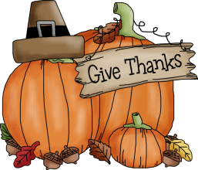 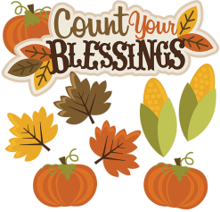

**Bobbie Noonan’s**

**November Newsletter**

November 2022

Upcoming Events

Veteran’s Day:

Friday, November 11th is Veterans Day. Remember all the past and current veterans and enjoy the day. School is open as usual. We also ask that you have your children dress in red, white and blue!

Election Day:

Tuesday, November 8th is Election day. In keeping with the spirit if the day, we will be hosting our own election. The children will participate in voting in some of their favorite things; books, characters, snacks and colors!



Mickey Mouse’s Birthday Celebration:

On Monday, November 18th we will celebrate Mickey’s birthday. Join us in the celebration by dressing your child in their favorite character shirt.

Progress Reports:

During the week of November 21st, Progress Reports will be sent home. No formal conferences will be done at this time. If you have questions concerning your child, please send a note to their homeroom teacher who will contact you regarding any of your concerns. Attached to each progress report is a brief description of general milestones that may help you to determine if your child is progressing at a normal developmentally appropriate rate.

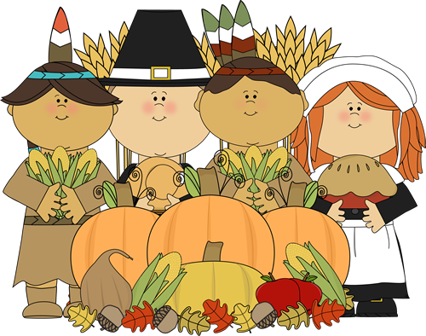

Day Care Parents:

As a special request, we are asking that toys not be brought to school. Please remember to bring your child’s cot sheet and blanket every Monday. If your child does not have a cot sheet, one can be purchased from the office for $9.50.

Thanksgiving Feast:

On Monday, November 21st and Tuesday, November 22nd all classes will be participating in a Thanksgiving Feast. This is a re-enactment of the first Thanksgiving. The children are going to learn about the meaning of Thanksgiving. This is a very exciting day!

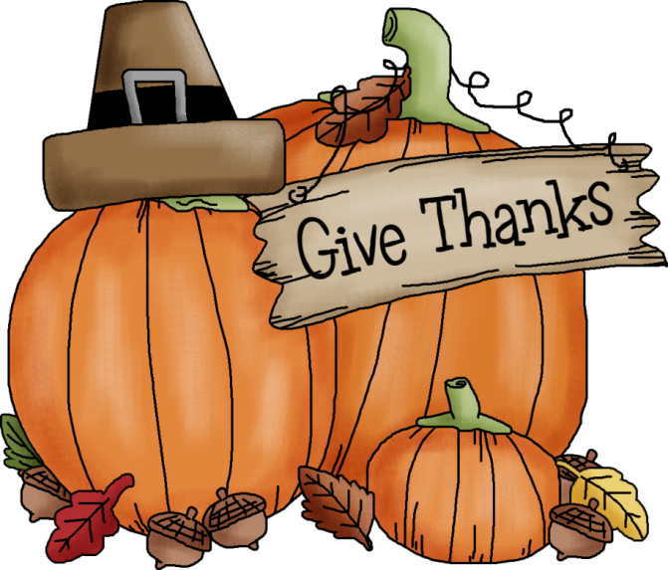

Thanksgiving Family Project:

We need your help! We are asking each family to decorate a turkey feather to represent your family! We will place the turkey feather on a turkey and display it in each classroom. Be creative and have fun with this project. We look forward to seeing the finally product and to hear what your family is thankful for! More information to come.

Thanksgiving Holiday:

School will be closed on Thursday, November 24th and Friday, November 25th in observance of the Thanksgiving Holiday.

Full tuition is due this week.

We are so very thankful for YOU allowing US to care for your CHILDREN!

.

Don’t forget to like us on Facebook!

You might see some pictures of our school and children.



Bobbie Noonan’s Information:

947 E. Division, Lockport, Illinois, 60441

Phone Number: 815-838-2855

Fax: 815-838-1654

Email: [lockport.director@bobbienoonans.com](mailto:lockport.director@bobbienoonans.com)

Please feel free to contact us with any questions by a note, email, or phone call.

Please Help:

Now that the weather is getting colder and the children are getting new outerwear, please remember to label all items with your child’s first and last name on them. We cannot be responsible for lost items. Also, please make sure that an extra change of clothes is in your child’s backpack and is for the appropriate season. It is very important that every child have a change of clothes in their backpack in case of spills or accidents. They feel much more comfortable in their own clothes. Thank you so much for your help with this matter.

Thanks..... for all your cooperation.

Thanks....for taking an active part in school activities.

Thanks....for your children who brighten each day for us.

Wishing you a very Happy Thanksgiving.

The Staff at Bobbie Noonan’s

