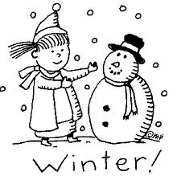 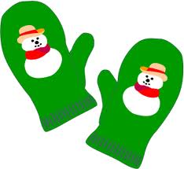

**Bobbie Noonan’s January Newsletter**

January 2023

Upcoming Events

**Student Evaluations:**

All the children will be re-evaluated this month and the results will be compared to those completed in September. This will help us to determine both how your child and the group as a whole are progressing academically and socially. We will use this information to plan appropriate curriculum for the months to come. Your child’s progress will be discussed at parent-teacher conferences in February. Specific information concerning dates and times will be sent out at a later time.

**Classes Resume:**

Welcome back and Happy New Year! Now that the excitement of the holidays have passed, all of us are ready to settle back into our regular routines. **Classes resume on Tuesday, January 3rd.**

**Help Wanted:**

Bobbie Noonan’s Child Care is currently looking for cooks and qualified teachers at a few of our locations. Please contact us for more information. Thanks!

**Martin Luther King Birthday:**

On Monday, January 16th, we will be celebrating Martin Luther King’s Birthday. School is open normal hours as usual.

**Registration for 2023-24 School Year & Summer Camp:**

Fall registration, for the 2023-24 school year will begin on Monday, January 16th. If your child will be attending Bobbie Noonan’s during the summer or next fall, please return the attached registration request form. The fall registration fee is $100.00 for one child or $150.00 per family. The summer activity fee is $30.00 per child. These fees are due as you return the completed forms. **At this time anyone who registers before January 31st is eligible for 50% off the school year registration fee.** Forms returned without the appropriate fees will not hold a spot for your child. Please understand that even if your child currently attends Bobbie Noonan’s they need to re-register for summer and fall. Remember in order to take advantage of our loyalty discount you will need to register by January 31st.

**Thank you:**

We would like to send a special thank you to all the families that remembered us during the holidays. We appreciate you so much!



Have a Wonderful Winter Season!

**Illness Policy:**

Now that winter has truly arrived-please remember our outdoor policy: Day care children will go outside everyday when the temperature is 25 degrees or above. (Wind chill factors will be taken into account). **Be sure to send appropriate clothing: winter coat, snow pants, boots, mittens and a hat (all items should be labeled with your child’s name).** Please keep in mind that we have a policy that if your child is well enough to be at school they are well enough to be outside. Listed below is our illness policy that you will find on page 25 of your parent handbook.

1. The child has a fever or had one during the previous 24-hour period. (Child must be fever free for 24 hours.)

2. The child has a cold and/or heavy nasal discharge.

3. The child has a constant cough.

4. If a child develops a communicable disease, please notify the school at once.

5. The child is overtired. Overtired children are susceptible to illness.

**Children must not be brought to school ill! We do not have the facilities to care for these children. Anyone who becomes ill will be isolated and the parent will be notified that he or she needs to be picked up in a timely manner. This policy is strictly enforced.**

**For Tax Purposes:**

For Income Tax Purposes our information is listed below for your convenience:

Bobbie Noonan’s Child Care

947 E. Division St.

Lockport, Illinois 60441

Tax Id Number: 36-416-1899

If you wish to receive a print out of your account, please contact the office in writing.

The Bobbie Noonan’s Staff

