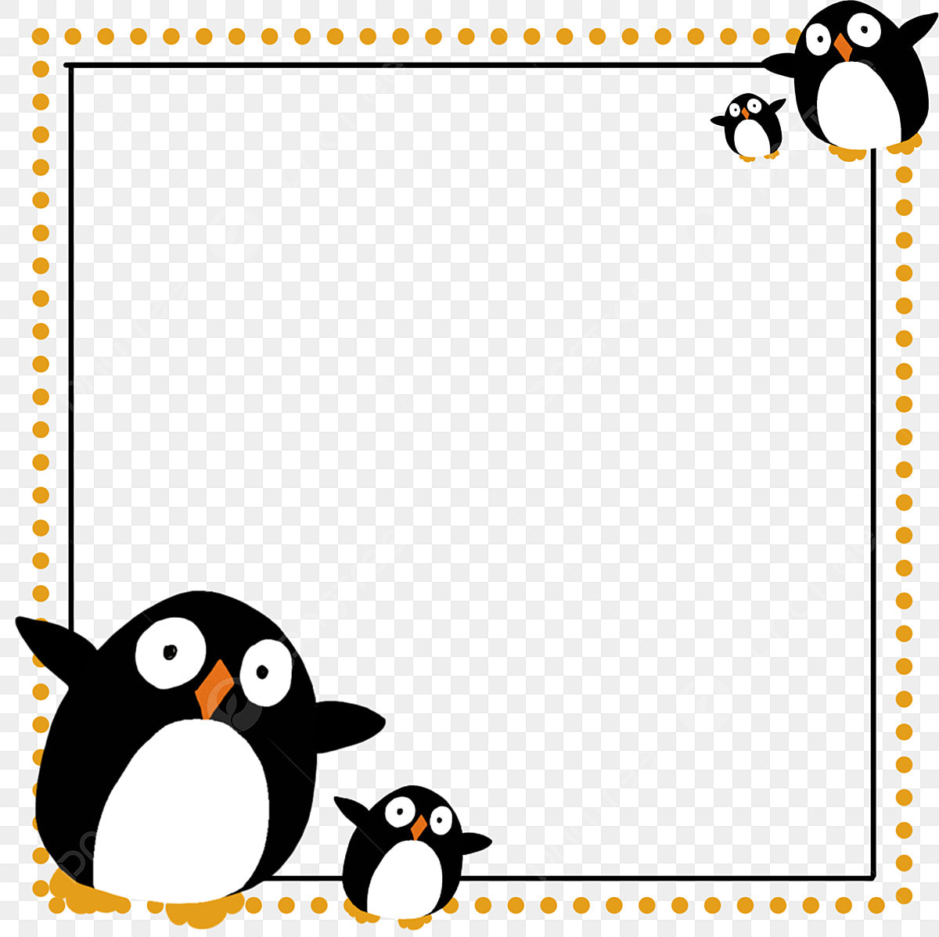

Toddler Times

Jan. 9-13 Theme: Penguin Parade

We’ll keep sliding into winter this week as we explore the topic of penguins. Process art will be enjoyed throughout the week as we puffy paint a penguin, mosaic a blue wintery scene, as well as ice cube paint. Songs for the week include “I’m A Little Penguin”, “Have You Ever Seen A Penguin” and “Penguins Attention”. A feed the penguin game will help us review our colors and shapes as we feed our puppet friend Patty the Penguin some colorful fish. Waddling around the room will be a fun gross motor game as we pretend to be a group of happy penguins!

**I’m A Little Penguin**

Tune: I’m A Little Teapot

I’m a little penguin

black and white.

I waddle to the left

and I waddle to the right.

When I’m feeling hungry

I splash and splish.

I jump in the water

and catch a fish.