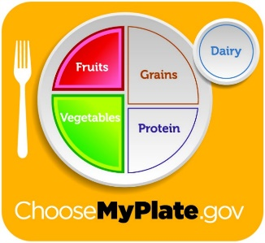
Bits of Intelligence: Midwest Wildflowers
Vocabulary: Locate – to find the place or position.
Limit – the point at which something ends or must end.

Junior Journal
January 9th -13th Week 22
Theme: Healthy Children

Language Arts
The Echo game, which is a game of following directions will be introduced to the children during Language time. A discussion of healthy eating habits will help the children learn the do’s and don’ts of a well-balanced diet. Ms. Christine will teach the children the importance of handwashing done throughout the day. Parents can help remind children to brush their teeth twice a day.
I Brush My Teeth
I brush my teeth in the morning.
I brush my teeth at night.
I brush them,
then I rinse them clean,
to keep them
strong and white.

Craft and Writing
Our papers will help the children understand healthy and unhealthy foods. Ms. Cheryl will discuss the “My Plate” and the importance of a balanced, healthy meal. The children will also review colors by completing coloring papers. Evaluations start this week so we will also be busy working on our fine motor packets.
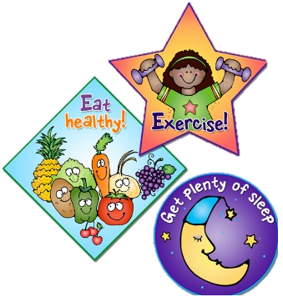
Introductions: Reading Story #3 “Run and Jump”
New Story Words: and

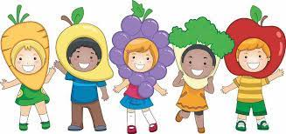

Concept
The focus this week is healthy children and we are going to discuss food groups and “My Plate” in addition to healthy eating habits. We will use straws to create shapes. To reinforce number concept the children will be given a card with a numeral on the top of it. They will be given blocks to count out the exact amount needed to match the number given.

Motor
Ms. Cheryl will begin the week with a book that reinforces good hygiene, titled Germs Are Not for Sharing. Ball play will require the children to kick a ball at a target. A simple path activity using hula hoops, blocks to jump over and small carpet squares to step over will add to the fun. A bean bag review game will help to reinforce all concepts introduced.

