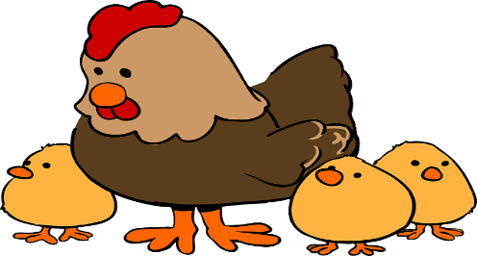
Theme: Farm
Pre K News
May 9, 2022

Let’s take a trip to the Farm and explore all that takes place on a daily basis. Introductions this week include story #13 with the words, Help, Work, You.

Chick Update. We have one more week to go before we see some cute little chicks! The children have been introduced to “chicken words” such as pullet, cockerel, waddle and comb. We will keep track of the peep’s growth inside the egg, and monitor the daily temperature and humidity level so we have a successful hatch!
Mrs. Paula, Mrs. Karen, Mrs. Julissa and Ms. Vickie
Happy Birthday!
Luke Clair 5/9

Language Arts: We will be talking and reading about all the different types of farms all over the United States, and the different crops and animals in each region. The children have been doing a great job reading their Bold Beginning stories. Keep up the good work!! The word family “ug” will be introduced this week.
Concept: On an imaginary visit to a Farm, we will find out what happens each month over the course of a year. Hopefully, we will discover some interesting facts. For example, did you know that May is one of the busiest months at the farm? Stay tuned to find out why! We will also learn about all the ways that farmyard animals help us.
Craft & Writing: We are working on rhyming and beginning sounds in our papers. A sheep will be created in art class this week. Fun Friday is on its way, and water color painting is on the agenda.
Motor: While outside this week, we will review all our manners including “Use your words, NO hitting”. Playing Farmer in the Dell and imitating farm animals will keep our muscles growing strong down on the farm.

Important Info
May 16 & 17-Hearing and Vision testing
May 25-Spring Show
May 30-Memorial Day, center closed
June 3-Last day of school

